Servlet/JSP Exercise

This exercise objective on using Servlet/JSP including with JDBC connect database and manipulate data with CRUD.

Table schema

**CREATE** **TABLE** ttransaction (

transid **VARCHAR**(50) **NOT** **NULL** **COMMENT** 'UUID',

userid **VARCHAR**(50) **NOT** **NULL** **COMMENT** 'tuser.userid',

transdate **DATE** **NOT** **NULL**,

journalid **VARCHAR**(50) **NOT** **NULL** **COMMENT** 'tjournal.journalid',

transno **INT**(11) **NOT** **NULL** **COMMENT** 'sequence number',

amount **DECIMAL**(20,4) **NOT** **NULL**,

remark **VARCHAR**(200) **NULL** **DEFAULT** **NULL**,

transtime **DATETIME** **NULL** **DEFAULT** **NULL**,

editdate **DATE** **NULL** **DEFAULT** **NULL**,

edittime **TIME** **NULL** **DEFAULT** **NULL**,

**PRIMARY** **KEY** (transid),

**UNIQUE** **INDEX** userid_trxdate_journalid (userid, transdate, journalid)

);

**CREATE** **TABLE** tjournal (

journalid **VARCHAR**(50) **NOT** **NULL** **COMMENT** 'UUID',

journalname **VARCHAR**(100) **NOT** **NULL**,

journaltype **VARCHAR**(1) **NOT** **NULL** **DEFAULT** '0' **COMMENT** '0=Payment,1=Receive',

amount **DECIMAL**(20,4) **NOT** **NULL** **DEFAULT** '0.0000',

editdate **DATE** **NULL** **DEFAULT** **NULL**,

edittime **TIME** **NULL** **DEFAULT** **NULL**,

**PRIMARY** **KEY** (journalid)

);

Specification

1. Create HTML & Java Script with AJAX to handle GUI like below

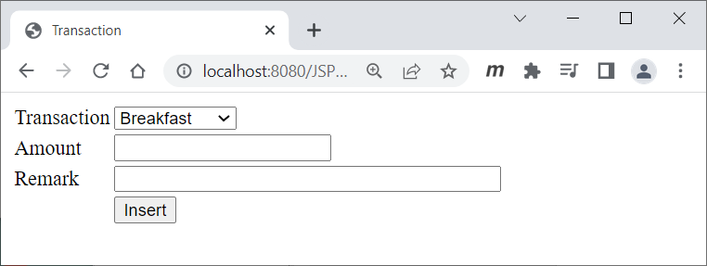

Example : screen insert

* 1. Transaction come from table tjournal with option value = tjournal.journalid and caption = tjournal.journalname
  2. Try to default Amount with tjournal.amount after selection changed

1. CRUD
   1. create : try to insert new record with input
      1. transid = UUID if not specified
      2. transdate = current date if not specified
      3. userid = ‘tester’
      4. journalid = Transaction from 1
      5. transno = 1
      6. amount = Amount from 2
      7. remark = Remark from 3
      8. transtime = current timestamp
      9. editdate = current date
      10. edittime = current time
   2. retrieve : with query statement

select ttransaction.*,tjournal.journalname

from ttransaction,tjournal

where ttransaction.transid = ?

and ttransaction.journalid = tjournal.journalid

* 1. update : with query statement

update ttransaction set amount=?, remark=? where transid=?

* + 1. transid = from retrieve
    2. amount = from input
    3. remark = from input
    4. editdate = current date
    5. edittime = current time
  1. delete : with query statement

delete from ttransaction where transid=?

* + 1. transid = from retrieve